 | Tip: | Picture:
Week 1: | Great Snacking Option for Kids  Our go to bar now offers a kid’s size bar. RX Bar Kids is the same RX Bar we love, just smaller and the perfect size for a balanced snack. The best part? It tastes just like a fruit roll up & is a sure hit with the little ones! | 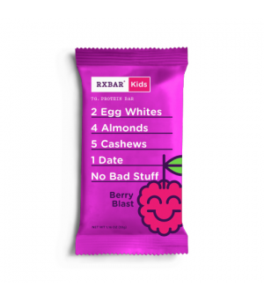
Week 2: | Sneaking Veggies In  It is not always easy for our kids to eat their vegetables. There are different ways to sneak veggies in their meal. Try pureeing veggies like peppers or mushrooms in a sauce or blending carrots in a Mac and Cheese recipe. Another option is to add mashed cauliflower into your mashed potatoes! | 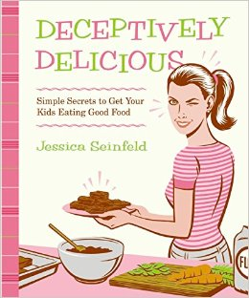
Week 3: | Smoothie Booster  A great way to enhance your child’s smoothie recipe is by adding the vegetables they probably won’t eat on their own. Adding kale or spinach to a smoothie is a great way to pack in nutrient rich vegetables into the refreshing drinks they love. Try our Green Machine smoothie recipe in our website. | 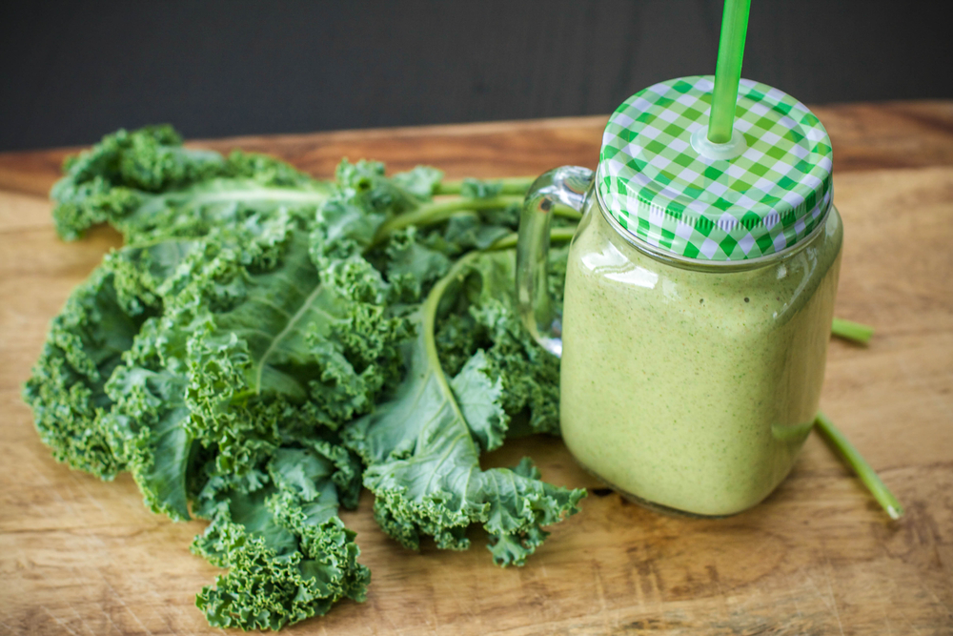
Week 4: | Top 3 Kid Friendly Vegetables  Learning to try new things is not always as easy as it sounds. Encouraging your kids to try new veggies is easier when you let them get involved with what they are trying.  Try to make it fun! Our 3 most popular veggies with kids are carrots, cucumbers, and peppers. Incorporate these veggies in fun recipes such as caterpillar kabobs, veggie dippers, and in a smoothie. | 