 | Tip: | Picture:
Week 1: | What are you measuring your success by?  Only looking at the scale is one way to set yourself up for failure. Try using multiple biometric tracking tools to measure your results.  What we use: InBody (measures lean muscle mass, body fat percentage, water weight, BMI), measurements and progress pictures  Looking to schedule an InBody Scan? Schedule one here! | 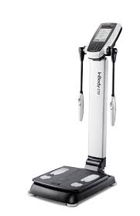
Week 2: | Who is your accountability partner?  Knowing that you have someone who is counting on you and is on your side will help you stay on track. Maybe you have a workout partner or someone with a similar goal as you.  Another option would be having a nutrition coach to follow-up with, review your food log and help you track your biometrics. Your nutrition coach would also help you alter your plan based on life’s circumstances and your progress. | 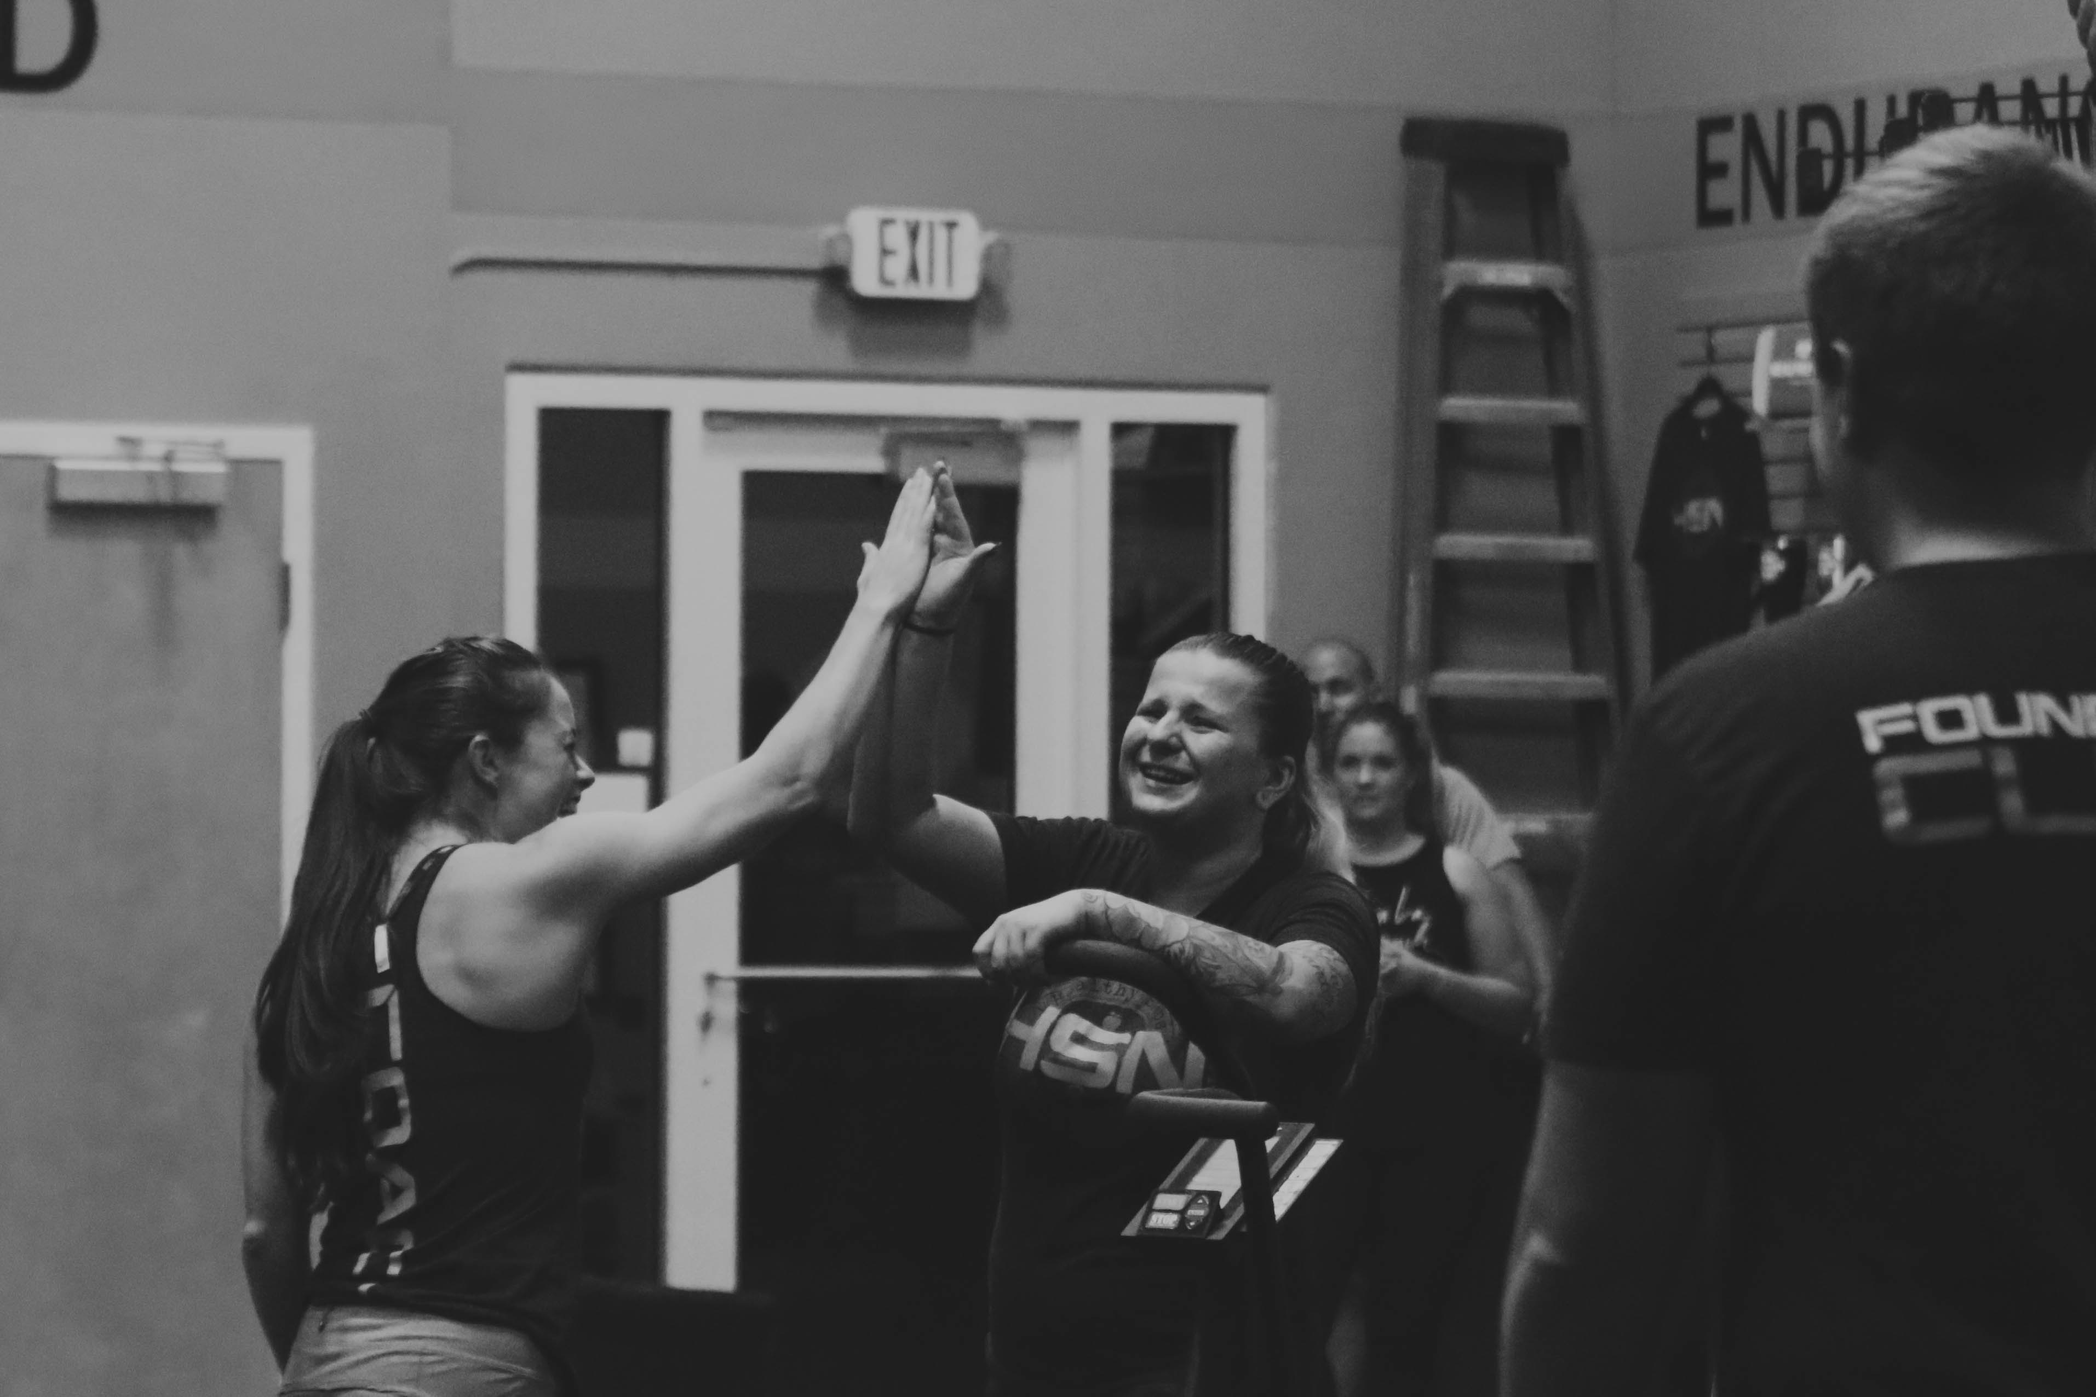
Week 3: | When To Track Your Food?  Tracking during the week and going off your plan or ”letting it rip” on the weekends is going to counteract all your hard work during the week.  Impulsive over eating has become socially acceptable, when in reality it is hindering you from achieving your long term success.  Pro TIP: Plan ahead. Calories still count even if you don’t log them in! Try tracking your food through MyFitnessPal even on the weekends to get a clear picture of what you are consuming. | 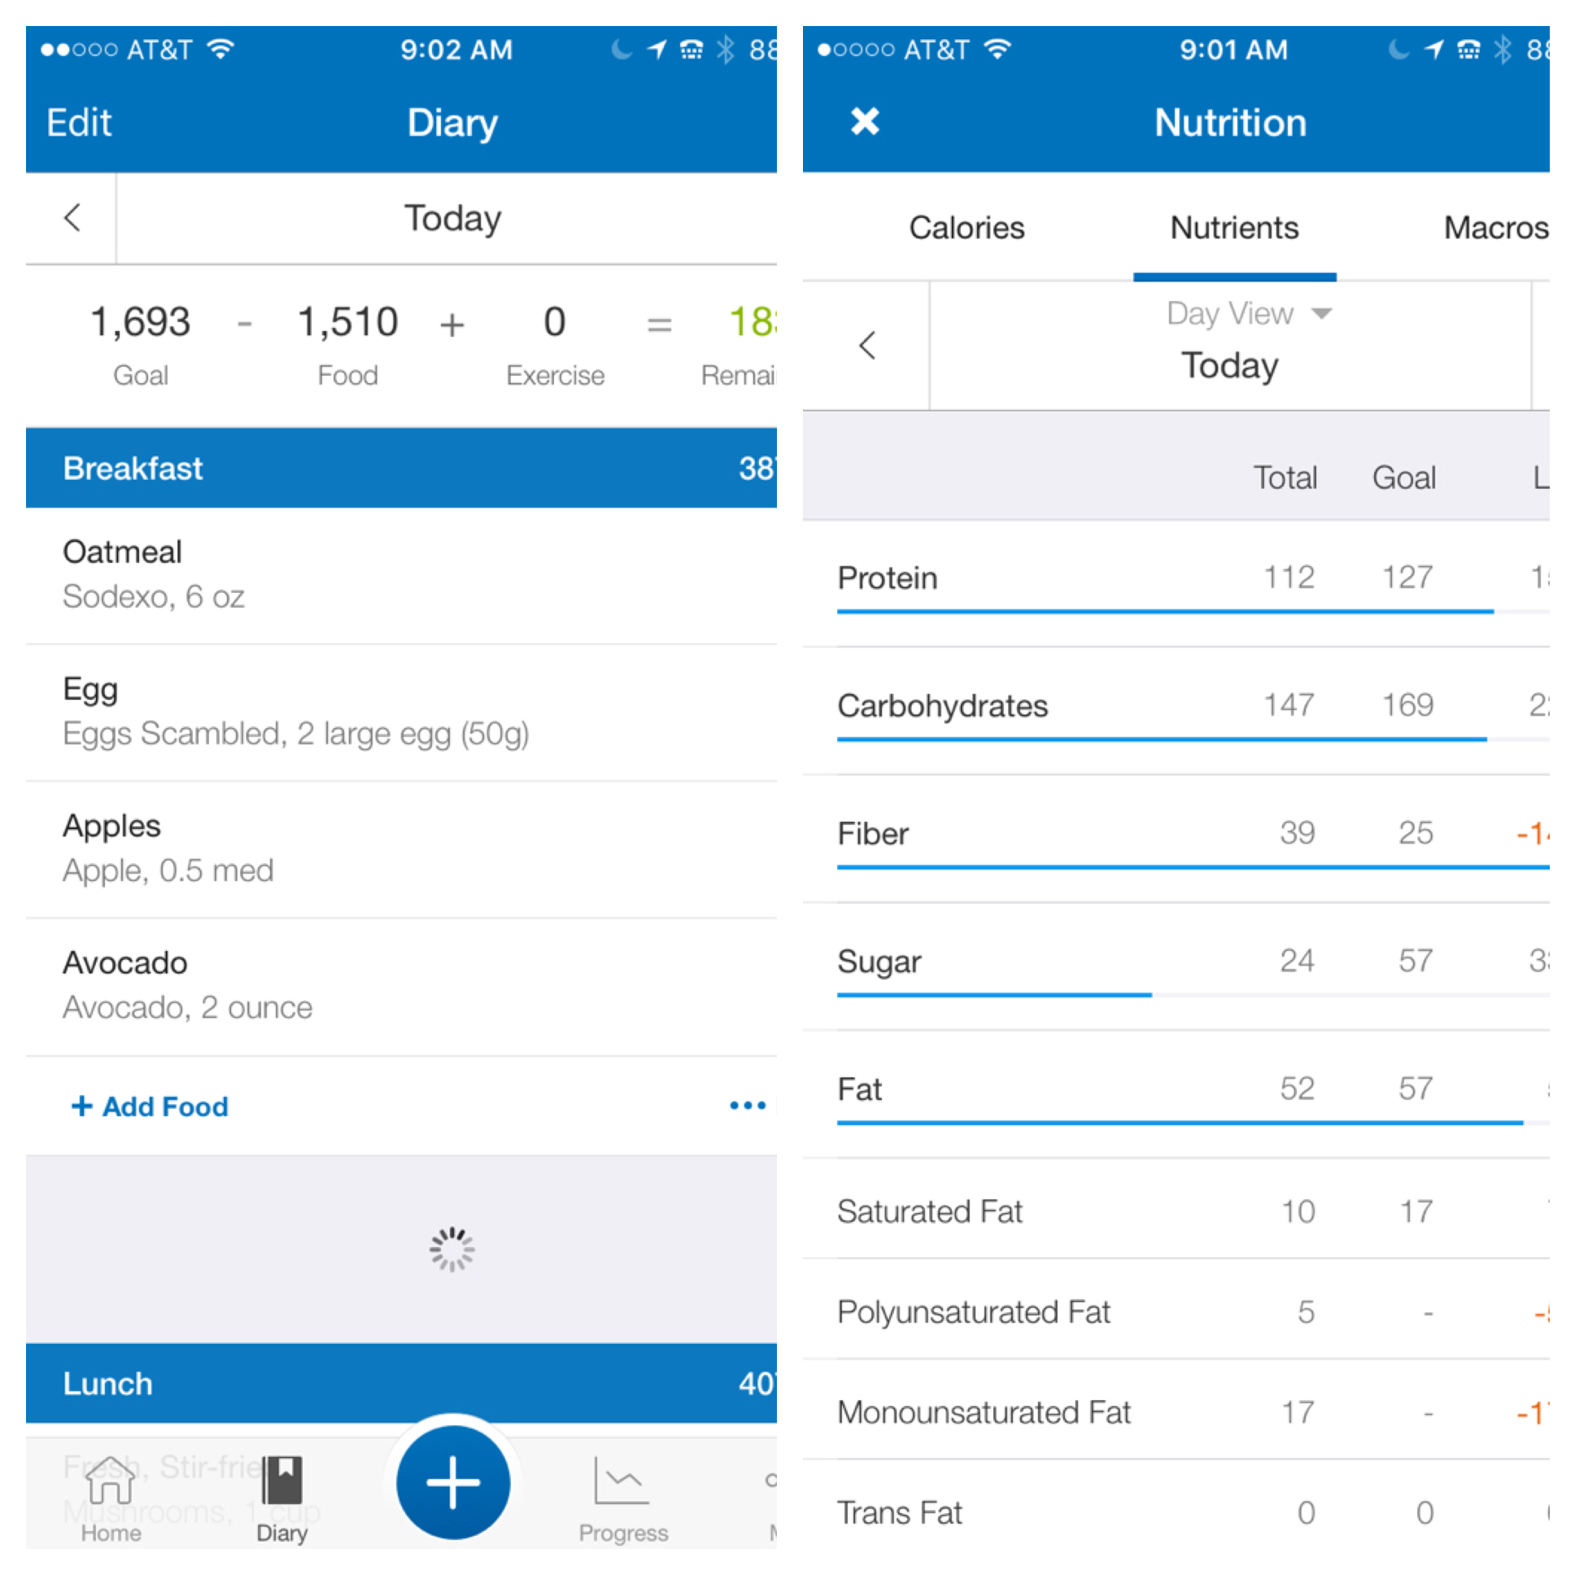
Week 4: | What Will An InBody Results Sheet Tell You Over The Number On The Scale?  We know that muscle weighs more than fat. If your body composition is changing and you are gaining muscle while losing fat, the number on the scale might stay the same or even go up. Then why evaluate progress based on weight?  Long story short, you shouldn’t base your progress strictly on weight. This is why we use a state of the art piece of equipment, an InBody.  The InBody results form shows lean muscle mass, skeletal muscle, water retention, body fat, muscle breakdown and basal metabolic rate. By measuring your progress with an InBody we can look at the full picture and adjust your plan as you achieve your goals. | 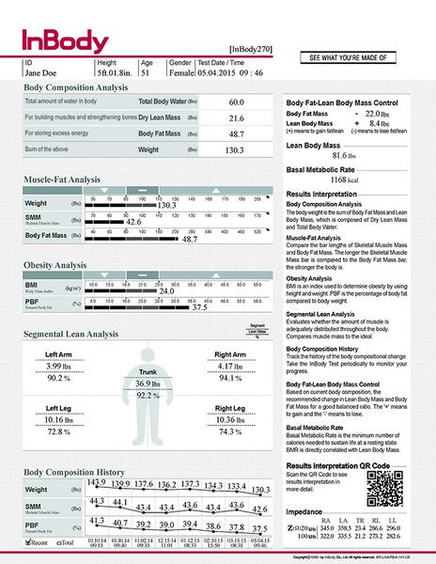
Bonus Week: | Plan Ahead!  Having a game plan while you are busy during the day, on the road or after a long day at work is vital to your long term success!  Take a few hours to prep on the weekend, use a crockpot and have convenient snacks with you. Skipping meals or snacks can lead you to be hangry or run through a fast food restaurant.  Try the RX Bar (Kids version), it’s the perfect snack size and loaded with protein. | 