 | Tip: | Picture:
Week 1: | How to Avoid Overeating at a BBQ?  - Have a snack before you go. Skipping meals leads to overeating later in the day.  - Slow down! Your brain is 15 minutes behind your belly.  - Load up your plate with veggies!  - Skip the bun and wrap your burger in lettuce. | 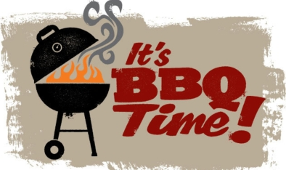
Week 2: | Stay Refreshed Without the Added Calories  Alcoholic beverages sound like the way to go on a hot day BBQ. Many of our refreshing summer cocktails are loaded with sugar. A Pina Colada contains 31 grams of sugar. Try a flavored sparkling water or adding a piece of lemon to your glass of water. | 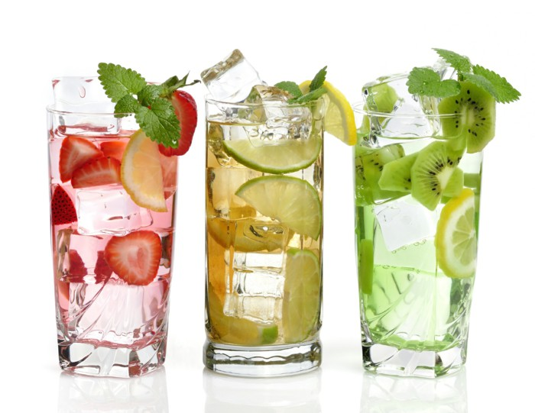
Week 3: | Bring a Healthy Dessert  Cookies and pies are all over. To avoid the temptation by bringing a bright and colorful fruit salad.  Try staying away from the ice cream, by having some Greek Yogurt. | 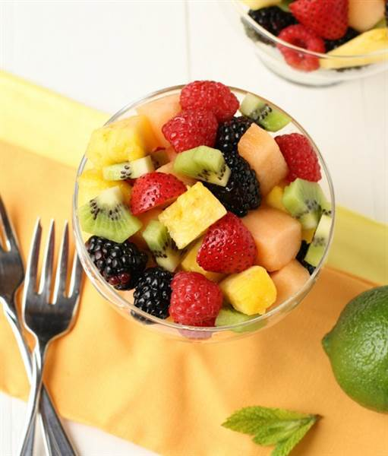
Week 4: | It Is Ok to Pass On Seconds  Whenever we're eating in a social situation, there can be a lot of pressure to eat more than we should. Just because someone offers you a second helping doesn't mean you need to accept.  Enjoy the social aspect of a summer BBQ and spend quality time with family and friends. | 