 | Tip: | Picture:
Week 1: | How much are you eating?  - Protein- about the size of the palm of your hand (and the thickness too)  - Starch- ½ - 1 fist (1/2-1 cup)  - Veggies- about the size of two fists! Load up on the veggies!  - Your thumb determines your fat portions.  PRO TIP:  Use the 3-compartment containers and smaller plates to help you stay on track! | 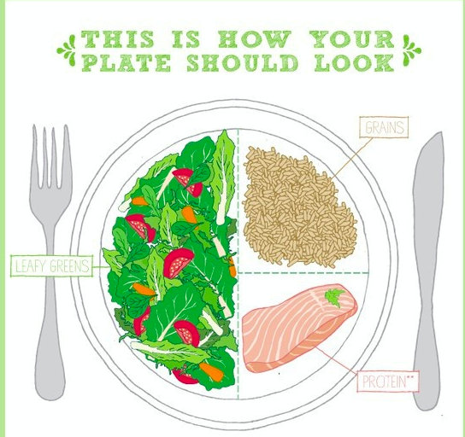
Week 2: | Be consistent & don’t skip a meal!  Did you know?  Skipping a meal will likely cause you to over eat later in the day and tends to lead to weight gain over time! Try eating small portions every three hours to avoid overeating.  PRO TIP:  Bring snacks with you or set a timer to remind yourself it’s time for a meal or snack. | 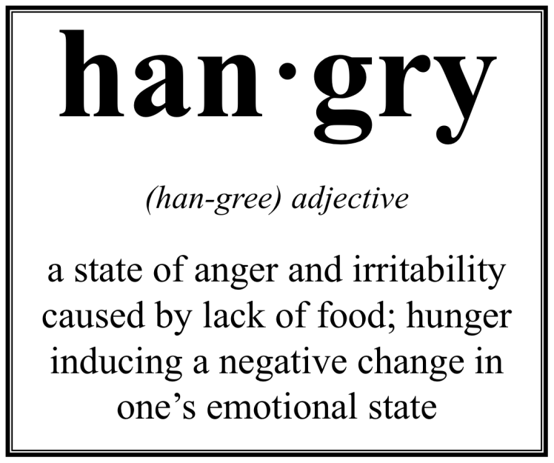
Week 3: | 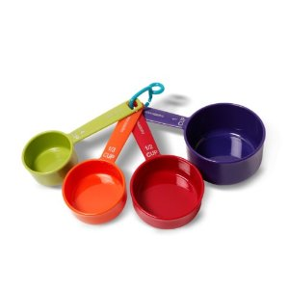  Are you eating what you think you are eating?  Many times we over-estimate how many calories we burn throughout the day and under-estimate the calories consumed. Maintaining a healthy weight is directly related to proper portion sizes! Time to dust off those measuring cups and do a spot check!  PRO TIP:  Make sure your cup and spoon is level when measuring, don’t heap or over load them.  It’s a mind game- If after measuring you feel that your meal is too small compared to what you normally eat, swap your big plate for a smaller one. This will help you feel more satisfied!
Week 4: | Portion Distortion:  Serving size vs. Portion Size  A portion is the amount of food that you choose to eat for a meal or snack.  A serving is a measured amount of food or drink, such as one slice of bread one cup of milk. Many foods that come as a single portion actually contain multiple servings.  PRO TIP:  Always check the nutrition facts labels  to determine the appropriate serving size! | 