 | Tip: | Picture:
Week 1: | We all LOVE pumpkin! Beware of the pumpkin flavored foods because they are loaded with sugar.  Try this delicious- Pumpkin Smoothie  - 1 cup unsweetened almond milk  - ½ cup pumpkin puree (not pumpkin pie filling)  - 1 scoop vanilla whey protein powder  - ½ teaspoon pumpkin pie spice  - 1 medium banana  - 6 ice cubes  Blend everything and enjoy! | 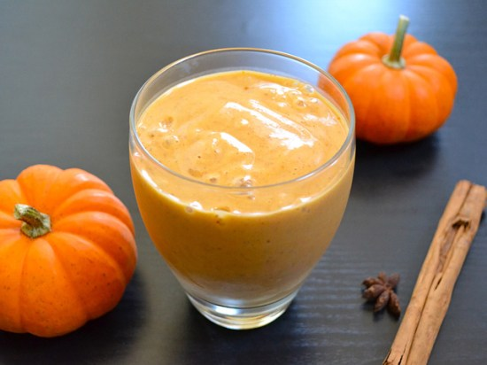
Week 2: | Brussel Sprouts  Did you know Brussel sprouts are a great non-starchy vegetable that is a good source of protein, iron, potassium, Vitamin C, antioxidants, and folate? Fill half of your plate with this delicious veggie for a healthy meal.  Check out our website for a healthy way to prepare your Brussel sprouts.  www.healthystepsnutrition.com | 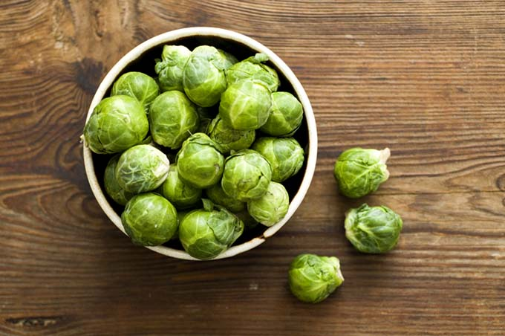
Week 3: | Swapping Recipes  Many of the holiday recipes we love are loaded with fat and carbohydrates. Try swapping your heavy holiday dishes with a lighter option. Check out our holiday recipes on the website. We have a mashed cauliflower, healthy stuffing and green bean casserole recipe. You can also try cauliflower stuffing instead of bread crumbs!  www.healthystepsnutriton.com | 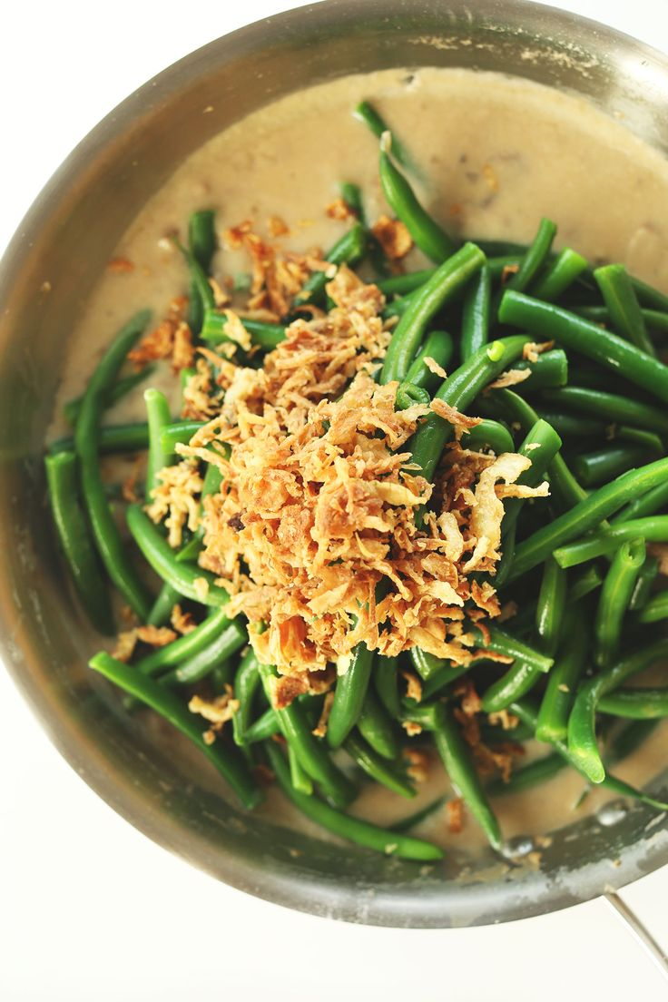
Week 4: | Healthy Food Swaps:  It is important to know how to substitute food choices that are not so good with healthier options to help you stay on track.  Choose these Instead of these  Applesauce for baking Butter/oil/shortening  Fat-free Greek Yogurt Ice Cream  Almond milk/skim milk Whole milk/creamer  Beams/carrots (pureed) Flour/cornstarch for thickening

