 | Tip: | Picture:
Week 1: | Think ahead  Check the restaurant’s menu before you go. Look for healthier choices available and see if they offer nutrition information on their website.  Fun Fact: Restaurants with 20 or more locations are required to give nutrition information for their meals. Restaurants have until May 7th, 2018 to add this information to their menus. | 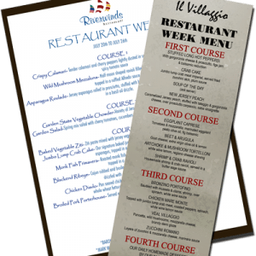
Week 2: | Substitute  Ask for a side salad with dressing on the side or a side of veggies to replace fried or carb heavy sides like fries and/or pasta.  Don’t be afraid to ask questions regarding preparation methods. Asking for these modifications such as no sauce or a lower calorie side will help you stay on track while eating out.
Week 3: | Portion Control  Have you ever over ate at a restaurant? It happens to all of us. Our brain is 15 minutes behind our belly and by the time we realize we are full; we have over eaten.  It doesn’t help when restaurants give portions 2-3x larger than what it should be. Ask for a box ahead of time and as soon as you get your food, box some of it and bring it home for a second meal later in the week.  See if you can split an entrée or ask for the lunch portion. Little tricks that help with portion sizes will go a long way.
Week 4: | Balance your plate  It is important to continue to balance your meals even when eating out.  Try to stick with the plate method. Load up your plate with veggies and eat all of those FIRST. Then move to your lean protein and save your starch for last.  Remember to put your fork down, drink lots of water and eat slowly. | 