 | Tip: | Picture:
Week 1: | Prep food staples  Try to buy/prep a few stables on the weekend that you can use in different recipes during the week.  For example, when cooking quinoa as a side for a chicken recipe, it can be used later in the week to a scrambled egg recipe. Spinach can be used in egg muffins, a smoothie & quinoa recipes. | 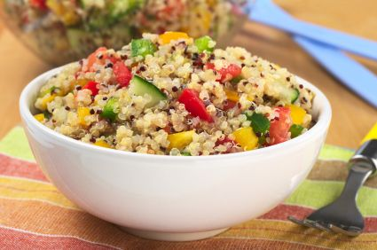
Week 2: | The Freezer Is Your Friend  Consider choosing recipes that are freezer friendly. This will help you save time prepping meals during the week because all you have to do is reheat it!  Make sure to label the food correctly and to use proper storage containers.  Freeze ready to go meals to throw into the crockpot. | 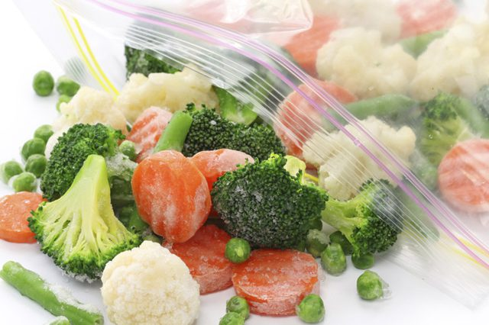
Week 3: | Plan Ahead  Time is the number one factor to making meal prepping successful. Sundays work best to get these meals done. 3-4 hours is ideal to spend on meal prepping including grocery shopping. This will save you time throughout the week and keep your meals fresh. Try using a crockpot, instant pot and even a muffin tin to help you meal prep!
Week 4: | Balance Your Meals  The perfect fuel combination of protein, fat, and carbs provides you with long-lasting energy and optimal metabolism levels.  Try using the 3-compartment containers to make sure you have the right balance of all the macronutrients while | 