 | Tip: | Picture:
Week 1: | Different colored fruits and veggies contain different vitamins and minerals.  You should have 2 servings of low glycemic fruits per day. Examples of low glycemic fruits include: berries, apple, orange, pear, peach, nectarine, plum and cherries.  What is your favorite low glycemic fruit? | 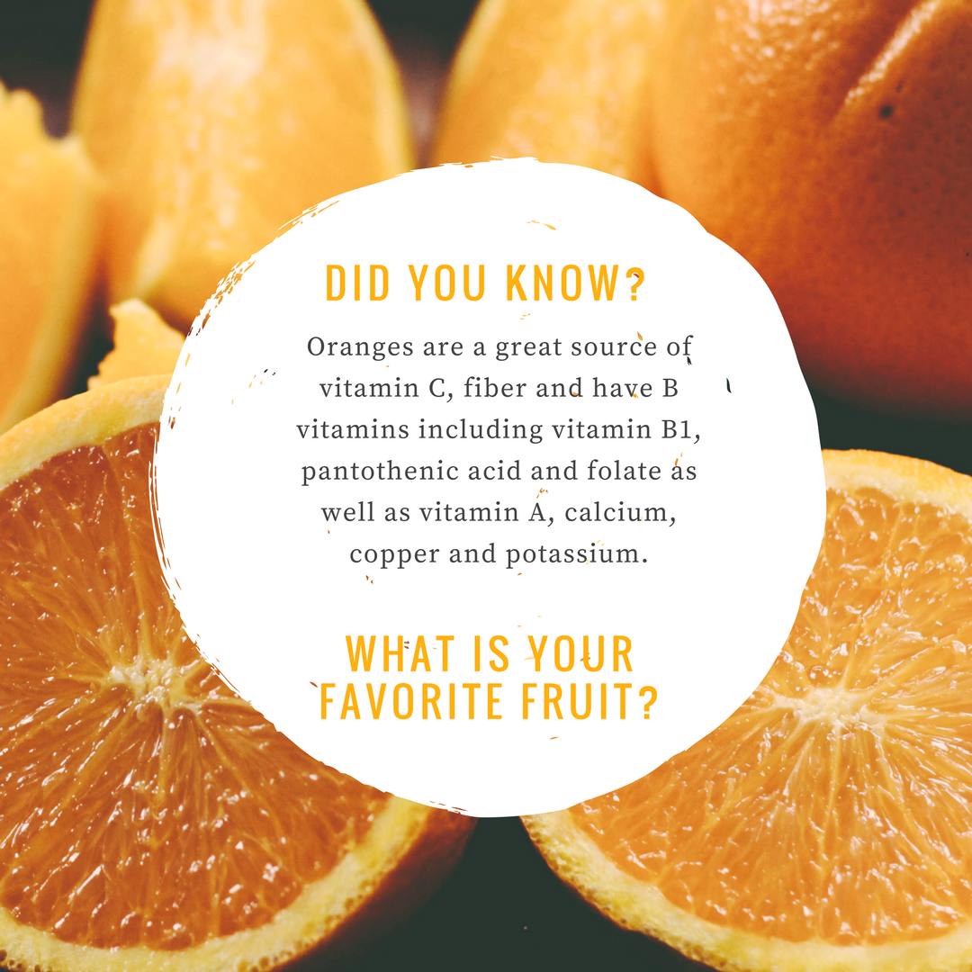
Week 2: | Meal prepping might seem tedious at first but it is vital to your success during the week. Try using a crockpot, muffin tin and 3-compartment containers to help make meal prepping easier.  You will find some great recipes here: https://healthystepsnutrition.com/healthy-recipes/  What is your favorite recipe to meal prep?
Week 3: | Looking at how far you want to go can be overwhelming. Instead of being paralyzed by looking at how far you have to go, commit to making one step in the right direction.  What is one thing you are committing to change to improve your health in 2018?
Week 4: | It’s easy to get distracted by the bright and shiny objects in front of you. You need a long term plan to achieve your health and weight loss goals.  What are your long term goals?  Write them down and let us know so we can help you stay accountable!

