 | Tip: | Picture:
Week 1: | Are you regularly logging your food?  If not, here’s 3 reasons why you should start TODAY!  Download graphic:  https://www.canva.com/design/DACuh8JH1VM/mjvJe_Sqq9h0Yvqp5BT_fQ/view?utm_content=DACuh8JH1VM&utm_campaign=designshare&utm_medium=link&utm_source=sharebutton | 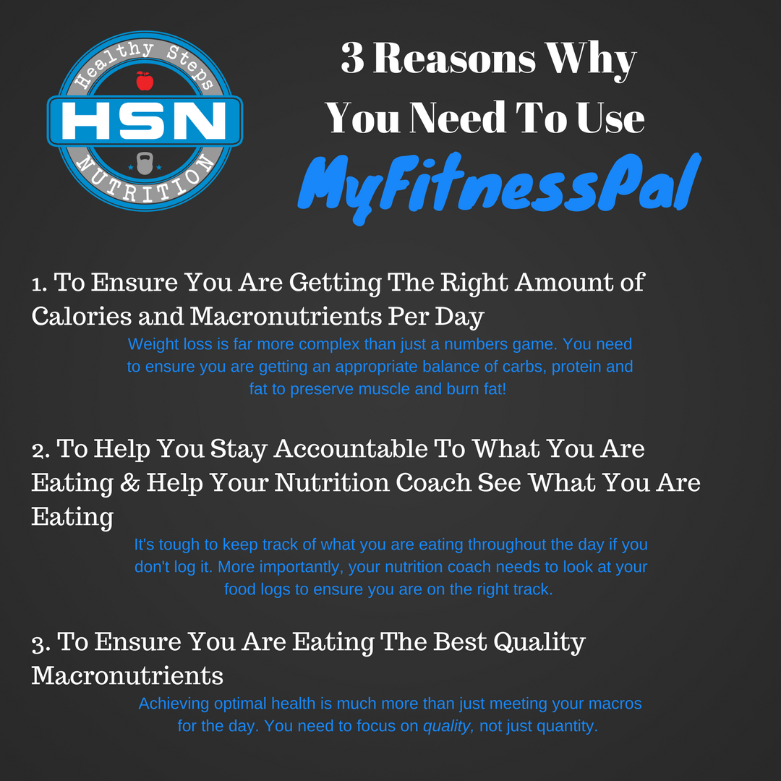
Week 2: | Did YOU Know?  If you like eating the same things every day, all you need to do is swipe right to add your usual breakfast! | 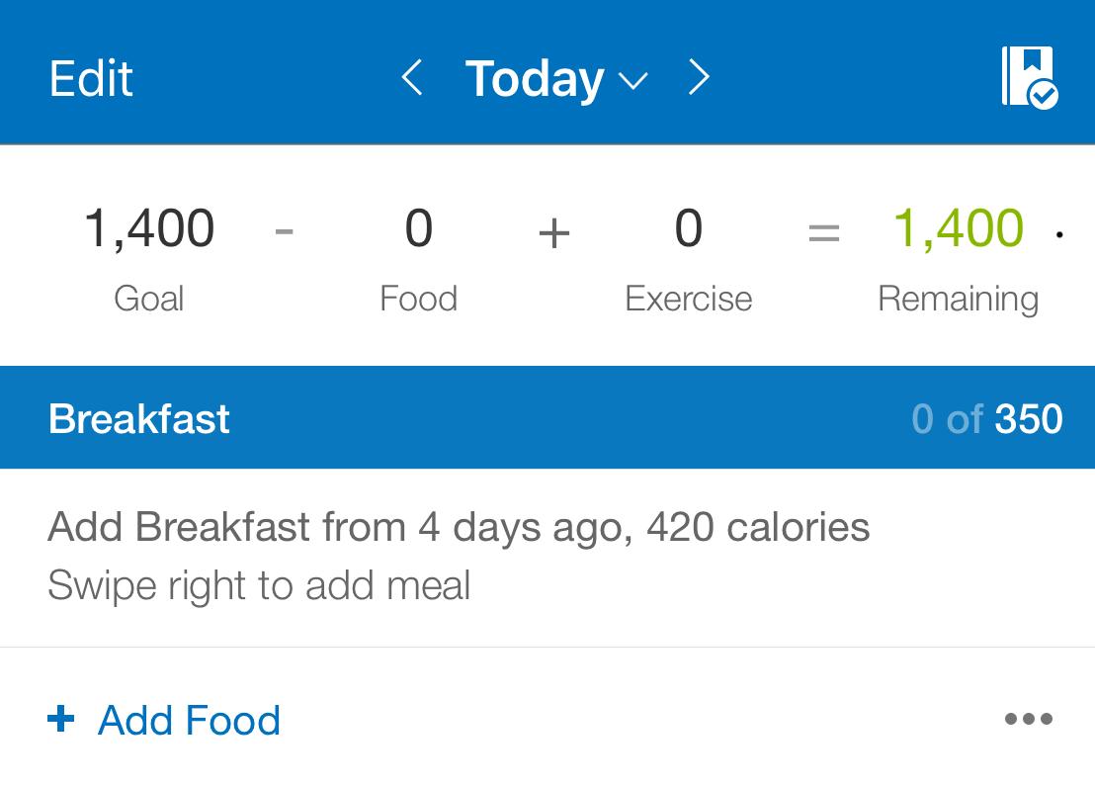
Week 3: | Logging your favorite HSN recipes just got easier!  The Healthy Steps Nutrition recipes can now be found on MyFitnessPal as a food! Just look for the (Official) next to Healthy Steps Nutrition to ensure it is the correct one! | 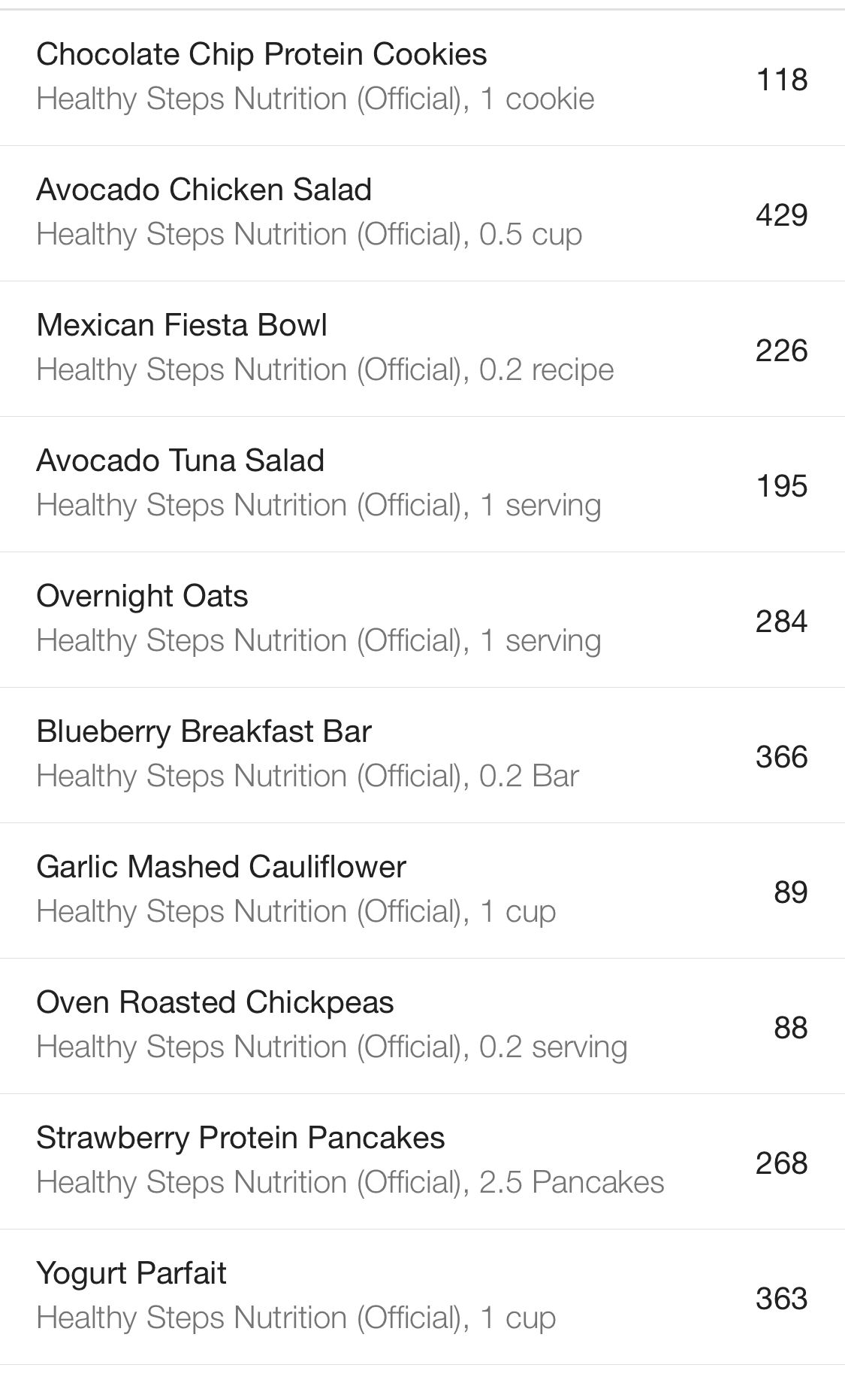
Week 4: | Do you know how close you are getting to your macronutrient goals each day?  Our NEW app allows our nutrition coach to see your total and goals each day to ensure you are on the right track! | 