 | Tip: | Picture:
Week 1: | Is your nutrition supporting or inhibiting you from achieving your health and fitness goals?  Schedule a No Snack Intro so we can help!  {Add link to your no snack intro}  Download graphic:  https://www.canva.com/design/DACwweyQutY/kRlHrnDa5rg_0unIm_SwFw/view?utm_content=DACwweyQutY&utm_campaign=designshare&utm_medium=link&utm_source=sharebutton | 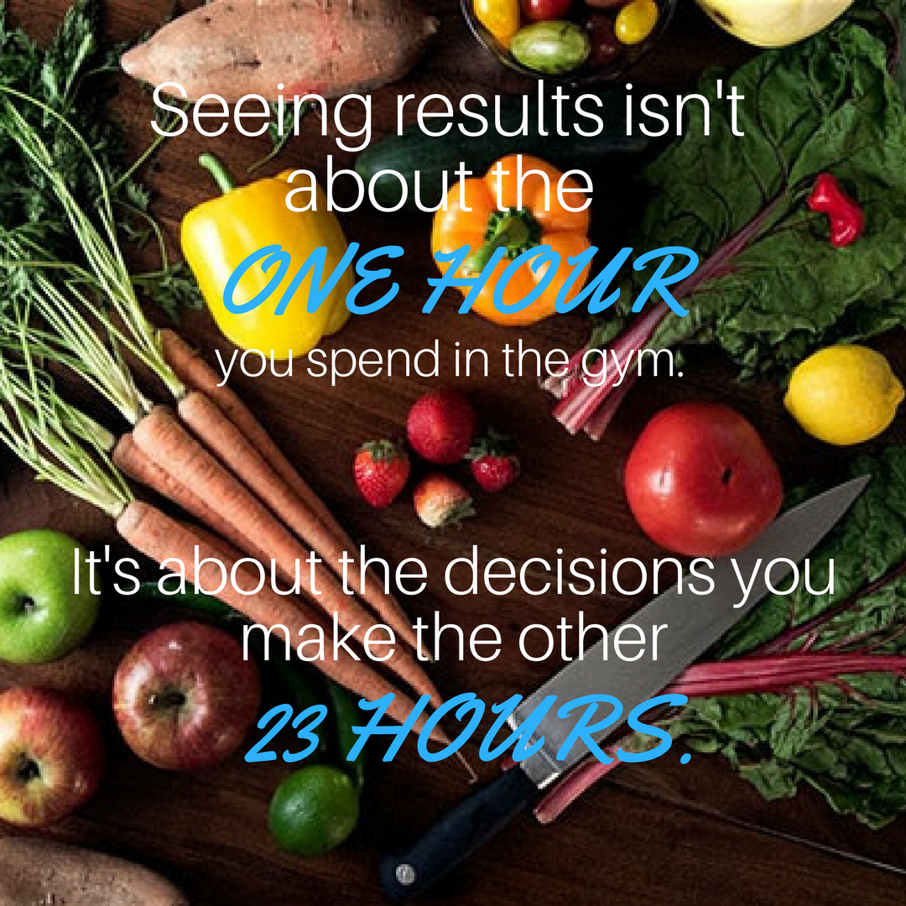
Week 2: | Restrictive diets don’t work.  You need a healthy lifestyle that focuses on ALL the pieces of the puzzle.  Schedule a No Snack Intro so we can help!  {Add link to your no snack intro}  Download graphic:  https://www.canva.com/design/DACwwj1nlrM/KLQIbqBVwOst-A7COeSRFA/view?utm_content=DACwwj1nlrM&utm_campaign=designshare&utm_medium=link&utm_source=sharebutton | 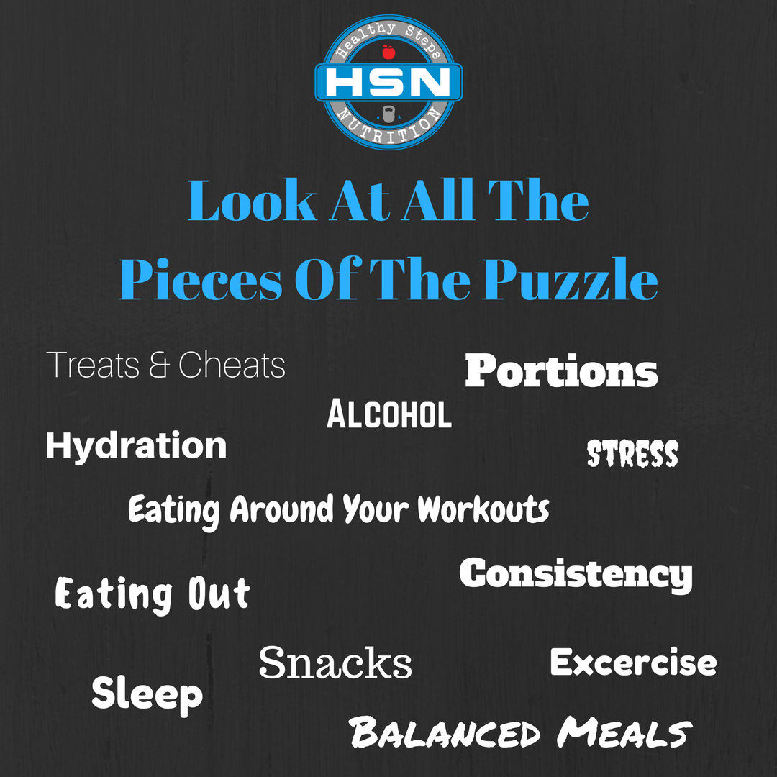
Week 3: | I recently had a client tell me, “Every time I start a diet it is because I have a wedding, birthday or an event. After the event is over, I fall off.”  Your nutrition plan shouldn’t have an end date, it needs to become your lifestyle.  Focus on your WHY. Start with long-term goals THEN break them down into short term goals. Set NEW goals when you achieve your short-term goals.  We would love to help. Schedule a goal setting session here:  {Add link to schedule goal setting session}  Download Graphic: https://www.canva.com/design/DACwwhFdaR0/qiG7KHd2tq0Vlwo9h2VQhw/view?utm_content=DACwwhFdaR0&utm_campaign=designshare&utm_medium=link&utm_source=sharebutton | 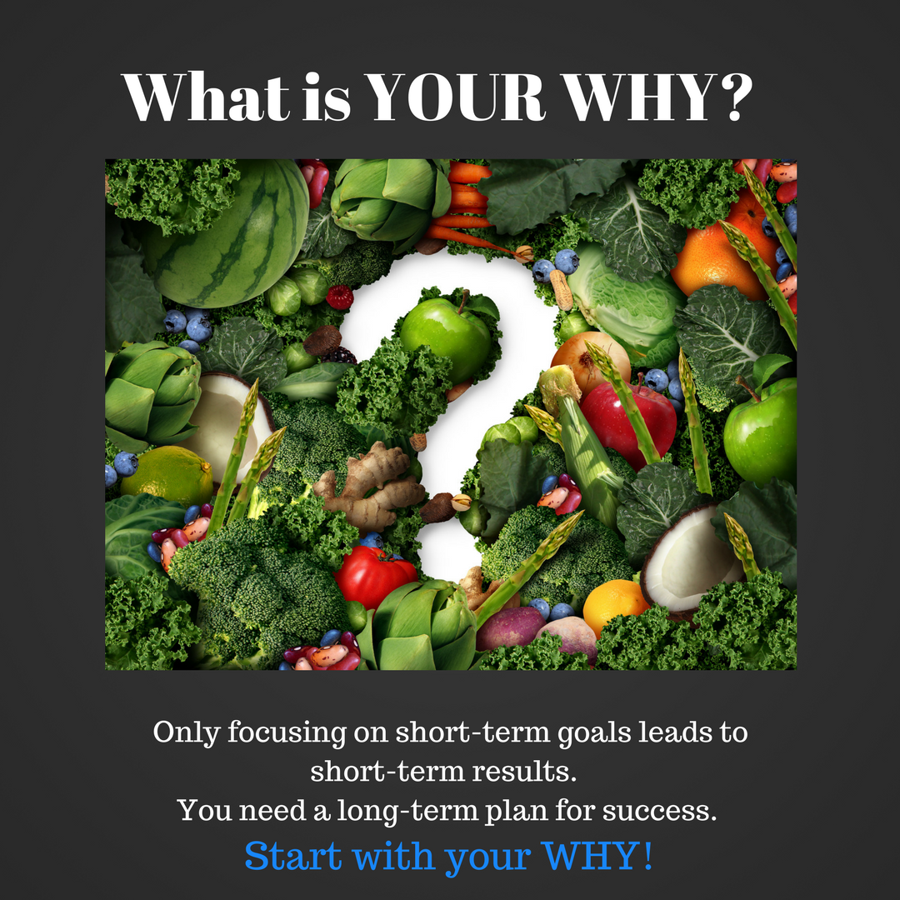
Week 4: | Long-term commitments yield long-term results.  What are you committing to that will help you achieve your health and fitness goals?  Download Graphic: https://www.canva.com/design/DACwwgDKXAA/G6znS3oDQeLRSte709_vaQ/view?utm_content=DACwwgDKXAA&utm_campaign=designshare&utm_medium=link&utm_source=sharebutton | 